Student Management System – Manage Student Details

# Project Overview

The Student Management System is a web-based application designed to store, manage, and update student information efficiently. It eliminates manual paperwork and provides a centralized system to track details such as student profiles, academic records, and course enrolment. The system ensures quick access to information and maintains accuracy, making it easier for administrators, teachers, and staff to manage students’ data. It also improves transparency and reduces redundancy in managing educational records.

# Abstract

Managing student data in educational institutions is often a time-consuming task when done manually. Errors, misplacement of records, and lack of centralized access are common challenges. The Student Management System provides a digital solution by automating the management of student details such as personal information, courses, grades, and attendance. This system offers secure data storage, quick retrieval, and user-friendly interfaces for administrators and staff. Built using standard web technologies with database integration, it reduces human error and saves time. The project demonstrates the practical application of full-stack development and database management concepts in solving real-world problems in education.

# Objectives

* To provide a centralized system for storing and managing student details.
* To reduce paperwork and manual effort by digitizing records.
* To ensure secure, accurate, and quick access to student information.
* To improve efficiency in handling student-related queries and reports.

# Problem Statement

In many educational institutions, student data is still managed using manual registers or spreadsheets. This method is inefficient, prone to errors, and time-consuming. Retrieving specific information often requires going through multiple records, which delays administrative processes. Moreover, manual management increases the risk of data loss, duplication, or misplacement, leading to poor decision-making and reduced productivity.

# Proposed Solution

The Student Management System addresses these challenges by providing an automated platform to manage student records. With a digital database at its core, the system allows administrators and staff to easily add, update, delete, or search student information. Unlike manual systems, it ensures accuracy, consistency, and faster data retrieval. The system also provides role-based access, so sensitive information remains secure. By reducing manual effort and errors, it enhances the overall efficiency of student record management in institutions.

# Features

* Add, update, delete, and view student details.
* Search functionality to quickly find student records.
* Course and grade management integration.
* Attendance tracking and performance reports.
* Role-based access for administrators, staff, and teachers.
* Secure login system with authentication.
* User-friendly interface with responsive design.

# Technologies & Tools

**• Frontend**: HTML, CSS, JavaScript, React  
• **Backend:** Node.js with Express  
**• Database:** MySQL  
• **DevOps Tools:** Git, GitHub, Docker, Jenkins  
• **Other Tools:** VS Code, Postman, Figma, AWS Cloud

# System Architecture

[ User ] → [ Frontend (React) ] → [ Backend API (Node.js/Express) ] → [ MySQL Database ]  
  
If DevOps is used: GitHub → Jenkins (CI/CD) → Docker → AWS Cloud → Monitoring

# Implementation Steps

1. Step 1: Requirement gathering / planning
2. Step 2: Frontend development
3. Step 3: Backend development
4. Step 4: Database setup
5. Step 5: Integration (frontend + backend + database)
6. Step 6: Deployment (manual or with DevOps pipeline)
7. Step 7: Testing and improvements

# Output Screenshots

# GITHUP REPOSITORY

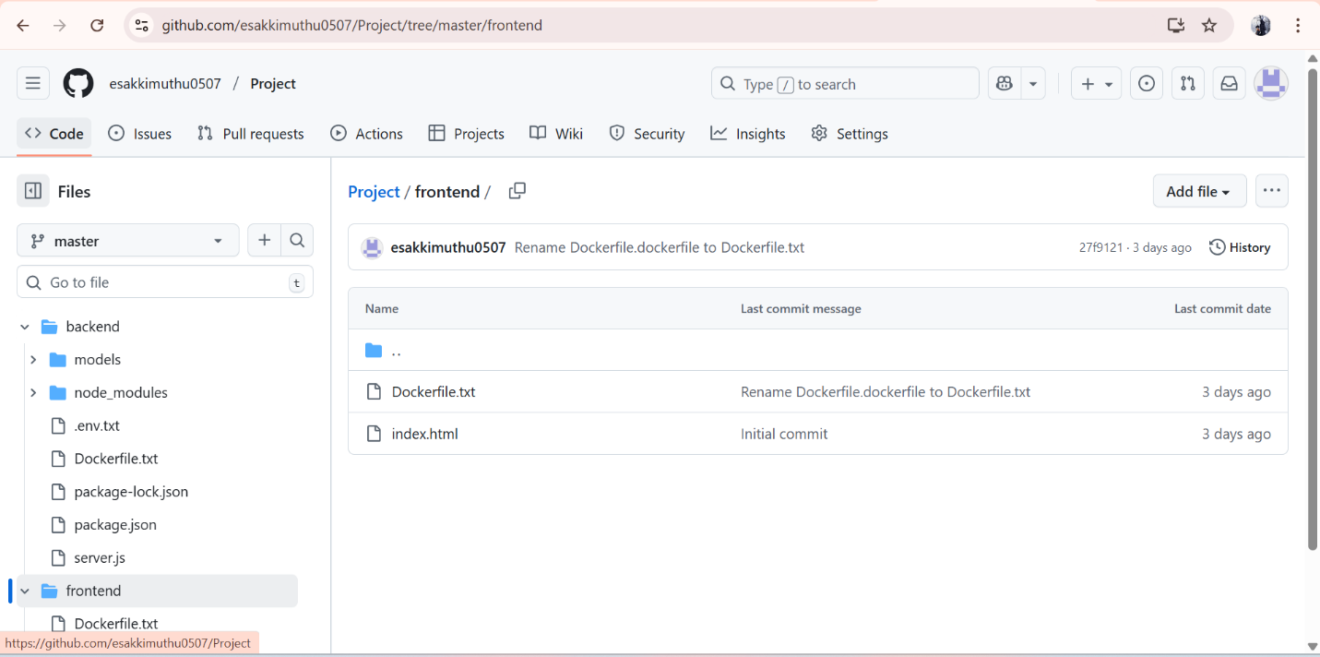

# Home Page

# 

# Add Record Form

# 

# List of Records

# 

# Advantages

* Saves time and reduces paperwork.
* Ensures accuracy and consistency of student data.
* Provides quick and secure access to records.
* Easy to scale with more features in the future.

# Future Enhancements

* Mobile application support for students and teachers.
* Integration of AI for student performance prediction.
* Cloud storage for secure and scalable data management.
* Online fee payment and receipt generation.
* Real-time notifications for students and parents.

# Conclusion

The Student Management System simplifies and digitizes the process of managing student records. It reduces manual effort, minimizes errors, and enhances efficiency in educational institutions. By integrating a user-friendly interface with a secure database, the system ensures that administrators and staff can easily handle student-related operations. This project not only demonstrates technical skills in web development and database management but also provides a practical solution to a real-world problem in the education sector.